Ryan Kladar s141094

Course: 02402 Intro Statistics

Project 2: Skive Fjord 2

4/11/2014

Part I: Analysis

1. The data collected by the Nat’l Maritime Monitoring Program available for this analysis is related to phytoplankton growth via phosphorus concentrations and chlorophyll concentrations. There is one monthly datum for each parameter (total phosphorus concentration in g/m3 and chlorophyll concentration in g/m3) for the years 1984 through 2003 (20 years inclusively). This results in a datum count of 720, or 240 points in 4 categories.

The median phosphorus concentration is 0.0704 g/m3 while the mean is 0.09036 g/m3. This difference results in a positive density skew, as shown in Figure 1. Other summary statistics are given in Figure 3.

The median chlorophyll concentration is 0.008670 g/m3 while the mean is 0.012094 g/m3. This difference results in a positive density skew, as shown in Figure 2. Other summary statistics are given in Figure 3.

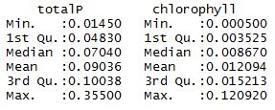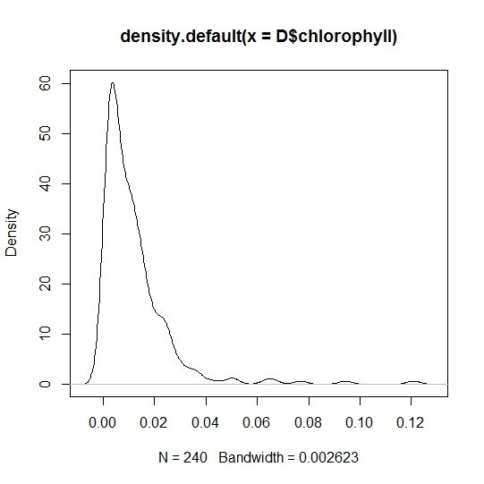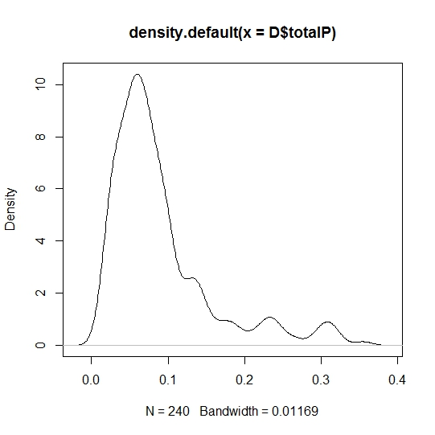

Figure 1

Figure 2

Figure 3

1. 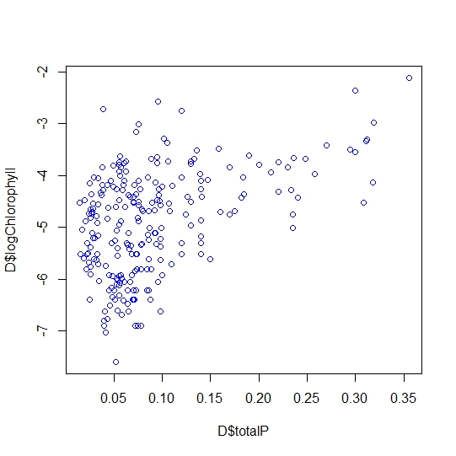

Figure 4: Shown is a scatter plot with the log transformation of the chlorophyll concentration vs. the concentration of phosphorus (both in g/m3). It is clear that as the concentration of chlorophyll (or rather, the order of magnitude of chlorophyll concentration) increases, so does the concentration of total phosphorus in the fjord.

( y) ̂ = β ̂_0+β ̂_1 x

1. A linear regression model of two variables, in this case the log of the chlorophyll concentrations and the total phosphorus concentrations, requires a calculation of an intercept term (typically β0), a single regression coefficient term (since we have one independent variable; typically β1), and an error, or residuals term (because it’s not perfect, it’s just a model; typically εi). The best model will minimize error, or residuals, based on the least squares sum method. To determine the least square estimates, we also use the regression terms β0 and β1. Each can be calculated using Equation 1, Equation 2, Equation 3, and Equation 4 below. For a linear regression model to be valid, we must make several assumptions about the data and variables. First, the dependent variable Y has some sort of linear relationship to X (Equation 1), which we observe in Figure 4. Next, for each value X (xi), the probability distribution of Y ( *P(a<Yxi<b)* ) has the same standard deviation, σy. We can assume this in most cases, but can also check this by plotting the residuals and observing that they are random. Finally, for any given X, Y values are independent (again checked in the random residuals plot, if not assumed) and roughly normally distributed (in this case, we have a large sample size, so skewness, like that observed above in Figures 1 and 2, is alright).

$β_{0}= \overline{Y}-β_{1}\overline{x} Eq 1$ $β_{1}=r×\left(\frac{s_{y}}{s_{x}}\right) Eq 2$

$β_{1}=\frac{ \sum_{i=1}^{n}{(Y_{i}}-\overline{Y})(x_{i}-\overline{x})}{S_{xx}} Eq 3$ $S_{xx}= \sum_{i=1}^{n}{{(x_{i}-\overline{x})}^{2}} Eq 4$

In this case, our independent variable, *x*, is total phosphorus concentration, and our dependent variable, *Y*, is the log of the chlorophyll concentration. *R* is the correlation (square root of the mean multiple R-squared). Sy and sx are the standard deviations of Y and X, respectively.

$$S_{xx}=s_{x}^{2}×\left(n-1\right) Eq 5$$

1. We can estimate the coefficients in the model using Equation 1, 2 (or 3), 4 (or 5) and the known means and individual values of totalP and logChlorophyll.

$β_{1}=\frac{ \sum_{i=1}^{240}{(Y_{i}}+4.902)(x_{i}-0.0904)}{S_{xx}}=6.7506$ or $β_{1}=\sqrt{0.2057}×\left(\frac{1.01255}{0.06803}\right)=6.7506$

$S_{xx}= \sum_{i=1}^{240}{{(x_{i}-0.0904)}^{2}}= 1.1061$ or $S_{xx}=s_{x}^{2}×\left(n-1\right)=1.1061$

$$β_{0}= -4.902-β_{1}×0.0904= -5.5123$$

We can calculate the standard error of our coefficients with Equation 6 and Equation 7:

$${SE}_{β1}= \frac{s_{y/x}}{\sqrt{\sum{{(x_{i}-\overline{x})}^{2}}}}=0.85985 Eq 6$$

$${SE}_{β0}= \sqrt{\frac{\sum{x_{i}^{2}}}{n\sum{{(x_{i}-\overline{x})}^{2}}}} =0.09718 Eq 7$$

We can also calculate our residual standard error using Equation 8:

$${SE}_{residual}= \sqrt{\frac{\sum{\hat{ϵ_{i}^{2}}}}{n-2}}=0.9043 Eq 8$$

For degrees of freedom, we must subtract two from our number of observations because we estimate both β0 and β1, limiting our freedom somewhat. Thus we get Equation 9:

$DOF=n-2=240-2=238 Eq 9$

1. We can check our calculations using the built in simple linear regression function in R (see R code included in supplementary materials.) Summarized below, we have two estimated coefficients, each with their own standard deviation, an estimate of the standard deviation of the errors, the number of degrees of freedom used in the estimate of the standard deviation of errors, and the variance of the explanatory variable.
$${\hat{β}}_{0}= -5.51215$$

$${\hat{β}}_{1}=6.7506$$

$$Standard Error_{β0}=0.09718$$

$$Standard Error_{β1}=0.85985$$

$$Residual Standard Error=0.9043$$

$$Degrees of Freedom=238$$

$$Variance of Explanatory Variable \left(Var(totalP)\right)= 0.004628$$

$$RMSE=0.2057$$

2. 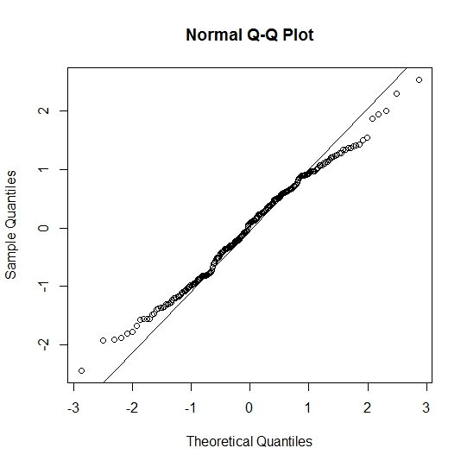

Figure 5. Shown to the left is the Q-Q plot of sample quantiles given with the data for the fjord vs. theoretical quantiles as calculated by our linear regression model. Included is the line of best fit for the plot, which shows good agreement along several deviations from the mean en either direction. The model performs more poorly as we get further from the mean, into the ends of the distribution, which is to be expected as point to point variation increases in these regions. The departure from normality challenges our assumption of normally distributed dependent variables, but verifies our observation of skew in the data. The large sample size is working against the skew of the data, decreasing the departure from normality. Had we not received as large a sample size, the departure from normality would be even more apparent and our model may need adjustment.

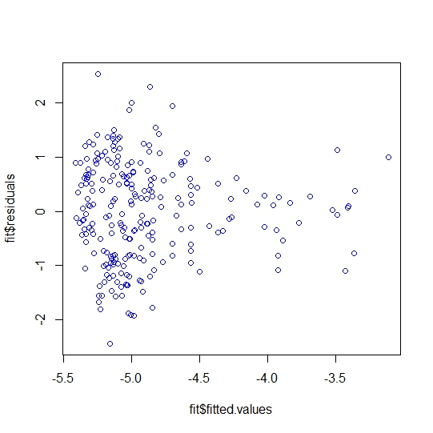

Figure 6. Shown to the left are the residuals vs. our fitted values. While there doesn’t seem to be a strong pattern in the residuals as a function of some part of the fitted values, we can clean up the image a bit, manipulating the residuals just to be sure. We can see a sort of trumpet shape to the data, hinting at maybe some sort of relationship. See Figure 7.

Figure 7. Shown is a series of manipulations done to the residuals and plotted against the fitted values, in an attempt to coax out any hidden dependencies not seen in the plot above. While there are an infinite number of transformations that could be performed on the residuals, here are basic ones often used to look at varying relationships. Clockwise from the top left, the manipulations to the residuals are: square root, squared, log, and antilog. We can see no discernible pattern in the residuals in any of them, so there are no hidden dependencies. Our earlier assumption that Y is a linear function of one variable, x, is correct.

.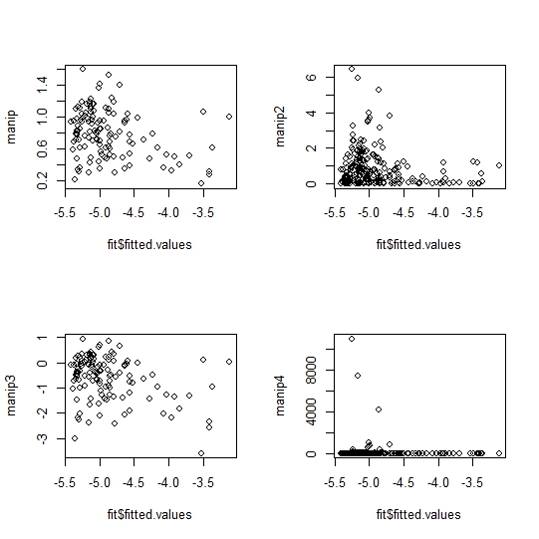

1. For calculating confidence intervals of the coefficients in the model, the general approach for calculating confidence intervals is used, with slight modifications for simplicity (Equation 10):
$$\overline{x}±t_{1-\frac{α}{2}}∙\frac{s}{\sqrt{n}} Eq 10.1$$

$$β_{1}±t_{α/2}×SE×\frac{1}{\sqrt{S_{xx}}} Eq 10.2$$

$$β_{1}±t_{0.975}×0.85985×\frac{1}{\sqrt{1.1061}} =\left[5.0567, 8.4444\right]$$

$$β_{0}±t_{0.975}×0.09718×\frac{1}{\sqrt{1.1061}} =\left[-5.7036, -5.3207\right]$$

2. It seems that the independent variable has an impact on the dependent variable. To be sure, we must test it:

H0 : *Ymean* = *β0*

H1 : *Ymean* ≠ *β0*

That is to say that if the mean of the dependent variable, Y, the log of Chlorophyll concentration, is not statistically significantly different than the intercept of the model (what Y would be equal to if our independent variable, X, the total phosphorus concentration in the fjord were equal to zero, or if it were not important, as is the case here), then the null hypothesis is accepted. If there is a statistically significant difference between the dependent variable and the independent variable term, the null hypothesis can be rejected. For this we need a test statistic, tobs, calculated with Equation 11:

$$t_{obs}=\frac{\overline{Y}- β_{0}}{s_{y}/\sqrt{n}}= \frac{-4.9021+5.51215}{1.0125/\sqrt{240}}=9.3385 Eq 11$$

Using this tobs and our confidence interval equations, we can calculate a 95% interval for the null hypothesis:

$$\overline{Y}=\left[-5.0309, -4.7733\right]$$

Pvalue = 2.2x10-16

With at least 95% confidence, we can say that the true mean of the log of chlorophyll concentrations is not equal to the intercept value of -5.5125, β0. We reject the null hypothesis and can state that phosphorus concentrations do play a significant part in chlorophyll concentrations in the fjord.

1. In December 2006, more measurements were taken, with totalPdec2006 = 0.0703 g/m3. Using our linear regression model, we can estimate the chlorophyll concentration at that point.

$${y=\hat{β}}_{0}+{\hat{β}}_{1}x= -5.51215+ 6.7506\left(0.0703\right)= -5.0379$$

To find the chlorophyll concentration, we must undo the log transformation:

$$e^{y}=chlorophyll concentration \ln{(chlorophyll}concentration)=y$$

$$e^{-5.0379}= 0.006489$$

We can find a confidence interval for this new concentration, which must involve both the error from the fitted model and the error associated with future observations. This confidence interval is also referred to as the prediction interval, and takes into account the uncertainty of the system (Equation 12):

$${\hat{β}}_{0}+{\hat{β}}_{1}x ± t_{1-α/2}× σ×\sqrt{1+\frac{1}{n}+\frac{{(x_{new}-\overline{x})}^{2}}{S_{xx}}} Eq 12$$

$$-5.51215+\left(6.7506×0.0703\right)± t_{0.975}×.9045×\sqrt{1+\frac{1}{240}+\frac{{\left(0.0703-0.0904\right)}^{2}}{1.1061}}$$

$$=[-3.2521, -6.8231]$$

Finally, undoing the log transformation:

$$e^{-3.2521}=0.038693$$

$$e^{-6.8231}=0.00109$$